John Shanrock, Joshua Smith

February 7, 2017

Laboratory 1: BJT Small Signal Parameters

**Objective**

This experiment serves as an introduction to using the laboratory equipment. Using knowledge gained in Electronics I, characteristics of a BJT were studied. Through intuitive changes to the provided circuit design, we were able to determine the four parameters which form the small signal model.

**Design Calculations**

Before beginning any physical experiment, we analyzed the design shown in *Figure 1* to determine the theoretical quiescent point position. The calculations for the theoretical determination of the quiescent point are shown below.

$$A_{v}=-\frac{2.7k}{0.3k}=-9$$

$$V_{BB}=\frac{3.9k}{18k+3.9k}×6V$$

$$R_{B}=3.9k||18k=\frac{1}{\frac{1}{3.9k}+\frac{1}{18k}}=3.21kΩ$$

$$V_{BB}=R_{B}\frac{I_{C}}{β}+V_{BE}+I_{E}R_{E}$$

$$V_{CC}=R_{C}I_{C}+V_{CE}+I_{E}R_{E}$$

$$⟹I_{CQ}=1.11mA, V_{CEQ}=2.67V$$

The calculations for the theoretical determination of the small signal model parameters are shown below.

$$h_{ie}=\frac{v_{be}}{i_{b}}=\frac{R_{s}}{\frac{V_{S}}{V_{be}}-\frac{R_{S}}{R_{1}||R_{2}}-1}=779.45$$

$$h_{fe}=\frac{i_{c}}{i_{b}}=\frac{i_{c}}{h_{ie}^{-1}V_{be}}=0.989$$

$$h_{re}=\frac{v_{be}}{v_{ce}}=0.262$$

$$h_{oe}=\frac{i_{c}}{v_{be}}=0.00158$$

**Conclusions**

Following the calculations, *Figure 2* was constructed and the desired values were measured. Then *Figure 3* was constructed and again the desired values were measured. These measurements, and the measurements of ICQ and VCEQ, are recorded in *Table 1*. Utilizing the measurements in *Table 1*, the theoretical values of the small signal parameters were calculated and tabulated in *Table 2* using the calculation methods described by the above equations.

One of the things we noticed in performing this experiment is that the BJT chips in the lab are highly unreliable. The bipolar transistor array had 3 transistors that we could use. The first chip under inspection produced values of VCE that were upwards of 2V off from the theoretical values. After finding a new chip, we were able to find a BJT which performed better than the previous 3, albeit noticeably different than it should have behaved theoretically. Since these BJTs quiescent point was much different than theory would suggest, the small signal system parameters that were measured do not match the calculated values. Recalculation of the small system parameters utilizing the measured quiescent values and actual resistor values would lead to a more accurate representation of the theory.

**Figure 1 – Single Stage CE BJT Amplifier**

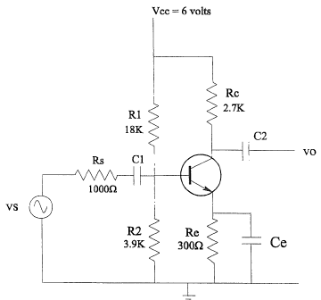

**Figure 2 – CE Single Stage Amplifier Configured for Determination of h­ie­ and hfe**

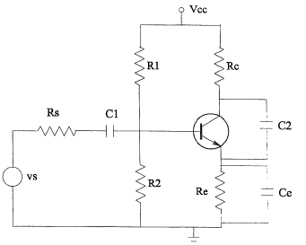

**Figure 3 – Modification for the Measurement of hre and hoe**

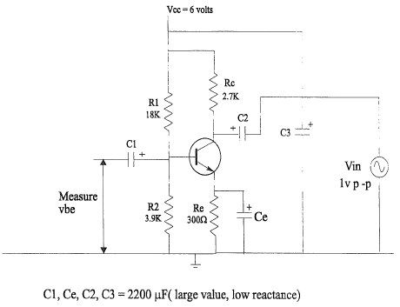

**Table 1**

|  |  |  |
| --- | --- | --- |
| **ICQ** | 0.00098A |  |
| **VCEQ** | 2.9722 V |  |
|  | **Figure 2** | **Figure 3** |
| **IC** | 0.00089A | 0.00087A |
| **VBE** | 0.72774V | 0.43122 |
| **VCE** | 3.1637V | 3.1530V |

**Table 2**

|  |  |
| --- | --- |
| **hie** | 1028 |
| **hfe** | 1.258 |
| **hre** | 0.137 |
| **hoe** | 0.00202 |